AI-Based Safety Perception Mapping System for Women Using Sentiment Analysis of Crowdsourced Text Data
Abstract
The women safety in public spaces continues to be a critical issue, especially in public spaces, as existing safety applications have been based on reactive safety mechanisms, including SOS and emergency response systems. However, there is a lack of perception-based information, which can be a valuable tool in decision-making before entering a particular space for women. This paper proposes a safety perception mapping system using AI, which analyzes crowdsourced textual experiences to provide preventive safety insights. The system provides users with the opportunity to submit anonymous feedback on their experiences at a particular space using a web-based interface. The feedback is processed using Natural Language Processing techniques such as text cleaning, tokenization, and removal of stop words. TF-IDF is then applied to the feedback. The sentiment in the feedback is classified as positive, neutral, or negative, which corresponds to safe, moderate, and unsafe conditions. This classification is done using a Logistic Regression model. The results are then visualized in a map based on the feedback provided. Unlike existing safety applications, which use crime statistics and GPS, the system focuses on community-based intelligence. Our system shifts AI towards proactive empowerment, mapping crowdsourced perceptions to guide women's decisions and foster community-driven urban safety.

Keywords: Sentiment Analysis, Public Safety, Natural Language Processing (NLP), Crowdsourced Feedback, Risk Assessment, Machine Learning.

- Introduction
Women’s safety in public spaces is one of the major issues in India, particularly in growing cities. According to the National Crime Records Bureau (NCRB) 2022 report, the total number of crimes against women reported was 445,256. This is an increase of 4% compared to the previous year, averaging almost 51 cases every hour [1]. Further insights from the 2025 National Annual Report and Index on Women's Safety (NARI), conducted from a survey of 12,770 women from 31 cities across the country, indicate that the overall safety score for the country is a mere 65%. In addition to this, 40% of women have stated that they felt that they were not safe [2]. When it comes to harassment, it has been stated that 7% of women have felt that they have been harassed at some point of time while at public spaces, with almost two-thirds of these cases not being reported. When it comes to cities like Pune, the poor infrastructure has been one of the biggest reasons why women have felt unsafe. This is reflected in the crime rate of 66.4 cases per lakh of women's population [3].
Despite these alarming statistics, the current safety solutions are ineffective in collecting perception-based information. Women's experiences are scattered across social media platforms, helplines, and other mediums. This leads to the loss of valuable information related to safety. Current safety solutions are limited to only reacting to situations that arise. For example, current safety apps provide SOS services that are only utilized during emergency situations. According to research, only a small percentage of such incidents are reported. Apart from this, it is also observed that about 70% of the women living in urban areas try to avoid night travels. This, again, stresses the importance of raising awareness instead of reactive mechanisms.
Community involvement is crucial in bridging this gap. Live experiences of women could provide specific and local information about the environment of safety. With the emergence of Artificial Intelligence and Natural Language Processing (NLP), it has become possible to process unstructured text data. Methods such as Term Frequency–Inverse Document Frequency (TF-IDF) vectorization and Machine Learning models like Logistic Regression could be utilized to extract sentiment and safety trends from huge text feedback by users and convert them to numeric data [4].
Experience-driven safety intelligence systems have the potential of being a game-changer, as they have the potential of changing the focus from safety responses to preventive awareness. This will empower the user through the provision of a visual representation of the data, as presented through safety maps [3]. This paper proposes an Artificial Intelligence (AI) based safety perception mapping system that analyzes women’s textual experiences and generates location-based safety insights.

Problem Statement
Even though there is a significant increase in the number of applications for women's safety, existing applications are mostly based on reactive technologies such as SOS messages, location sharing, and emergency response services. These applications are heavily dependent on immediate responses and interventions, which may not be effective due to certain limitations such as response time, connectivity, and the ability to send emergency messages during critical situations [5]. Another major problem with the current solutions is the absence of mechanisms to utilize the safety perception data collected from the experiences of women. For example, the feelings of insecurity while moving to public spaces like dark streets, lonely routes, and unsafe transportation modes are subjective and are not documented effectively [6]. These perceptions can play critical role in the preventive aspects of safety solutions.
A further issue is that the public complaints on the existing safety issues are generally unstructured and scattered on various platforms. This problem causes inefficiencies in the detection of patterns and possible risks, which is a major limitation of the existing safety solutions. Furthermore, there is a clear lack of AI-based analysis techniques that can aid in processing textual safety experiences. Most of the existing applications fail to utilize NLP and machine learning to identify meaningful patterns and sentiments within the experiences shared by users [7]. Lastly, the existing applications have no perception-based safety mapping techniques that can aggregate experiences shared by users to produce safety insights for specific geographical locations [5]. Hence, proactive decisions and preventive safety awareness remain limited.

Objectives of the Proposed System
The AI-Based Safety Perception Mapping System for Women is a system that attempts to provide users with meaningful information on safety. The system is expected to provide safety-related feedback from users via a web interface, where users, especially women, can provide location-based safety information and share their experiences. The textual data provided to the system will be analyzed to obtain information through NLP techniques such as text processing and TF-IDF vectorization. The system will use machine learning to classify the sentiment of the safety-related information provided to it by users, which includes Positive, Neutral, and Negative, representing Safe, Moderate, and Unsafe conditions, to determine the safety perception of a particular area. The system will also use its ability to provide users with information on the safety of different areas through the experiences of users and assign different levels of risk to those areas. The system will provide users with safety-related information via an interactive interface, including color-coded maps, to enable users to easily understand safety levels. The system will provide data-driven and preventive safety awareness, enabling users to make informed decisions based on user experiences, as opposed to relying on emergency response mechanisms.

- Literature Survey

  - Existing Research Work
Patil et al. (2025) proposed a framework for quantitative sentiment analysis for women’s safety in their research. This framework was proposed by utilizing Natural Language Processing methods such as TF-IDF and Bag-of-Words, as well as machine learning methods such as Logistic Regression and Support Vector Machine. This framework was trained on a dataset containing 10,000 tweets, and an accuracy of 85.2% and an F1-score of 82% were obtained, along with a negative sentiment of 68% in post-incident tweets [8]. Gokulakrishnan et al. (2022) developed a Twitter-based sentiment analysis system, in which a combination of machine learning and deep learning algorithms such as Support Vector Machine, Random Forest, and Long Short-Term Memory was applied to analyze 50,000 tweets and detect trends and geographical differences in sentiment, with F1 scores of 84% (SVM), 86% (RF), and 89% (LSTM) [9]. Ranjitha et al. (2022) applied used Supervised Machine Learning techniques such as Support Vector Machine, Naive Bayes, and Random Forest to examine around 25,000 tweets regarding women safety in India, the SVM technique achieved 88.1% precision [10]. These studies highlight the effectiveness of machine learning and NLP in large-scale sentiment analysis using social media data.
P. Sharma and A. Jain (2023) presented a sentiment analysis system using TextBlob and Logistic Regression to analyze tweets related to women's safety. This system processed 5,000 tweets with 78.5% precision and 76% recall and represented the region of negative sentiment as unsafe zone [11]. Kumar et al. (2019) conducted a research to study the perception of safety for women in Indian cities using machine learning algorithms on Twitter data. In this research, TF-IDF features and classifiers like SVM and NB were used. The accuracy of the results was found to be up to 84.3% and 81% for SVM and NB, respectively. In this research, it was found that 92% of the sentiments in metropolitan regions were negative [7]. These approaches focus on polarity-based classification and urban safety perception trends.
R. Mano Ranjini et al. (2025) proposed a framework for evaluating women’s safety in urban regions. This framework is based on various data sources such as crime statistics, CCTV, and Twitter data, and is based on machine learning algorithms such as Random Forest and K-NN, with an accuracy of 87.26% in testing and 92.5% in training, with 1,200 spatial grids, and Dijkstra’s algorithm for route recommendations [12]. S. Verma et al. (2020) developed a spatial-temporal machine learning model to determine safety in public transport buses using 1,500 criminal activities. The proposed framework was successful in predicting the criminal hot spots with an accuracy rate of 80.2% [13]. Shenoy et al. (2021) designed an innovative framework for analyzing crimes and enhancing women’s safety using the Geographic Information System (GIS), attaining 85% recall on identifying crime hot spots [14]. These systems rely heavily on structured datasets such as crime records and infrastructure for safety evaluation.
Gargiulo et al. (2020) proposed a qualitative GIS-based safety perception mapping system by incorporating environmental factors such as lighting, visibility, and vegetation. The study revealed that environmental factors contribute to almost 70% of the safety perception and produced a safety index ranging from 0 to 1 [15]. S. Chen et al. (2024) proposed a system for evaluating safety perception in urban environments by using street-view images with CNN and ResNet neural network structures, achieving an accuracy of 76.4% and exhibiting a negative relationship between vegetation and safety perception of −0.32 [16]. Torra et al. (2022) analyzed the SafetiPin crowdsourced safety mapping platform using GIS-based survey methods and indicated that 65% of the locations were considered to be unsafe [17]. Trang Le (2022) performed a critical analysis of crowdsourced safety mapping platforms such as SafetiPin through examining 500 data points, revealing that 72% were affected by exclusion bias [18]. These studies emphasize spatial, environmental, and participatory approaches to safety perception.
V. Prerana and K. Rao (2025) proposed an AI-powered threat detection system based on computer vision, YOLO and deep learning techniques in detecting harassment and abusive content on social media platforms, where BERT achieved a recall rate of 92% on a dataset of 20,000 posts [19]. Wagh N. R. and Sutar S. R. (2023) introduced a multimodal deep learning framework that uses text, images, audio, and video for emotion recognition, achieving 95.3% accuracy compared to 85% in unimodal systems [20]. These approaches show the advancement of deep learning and multimodal AI techniques in safety-related applications.
Dolly Daga (2021) developed the Suraksha smartwatch system using GPS and motion sensing, delivering alerts at 100% efficiency [21]. Mandapati et al. (2015) proposed the I Safe mobile application with SOS alerts, GPS tracking, and fake call generation, achieving 95% success in alert triggering [22]. Kavitha et al. (2023) developed a safety device using GPS and GSM technology with 98% reliability in alert transmission [23]. Akram et al. (2019) developed an IoT-based safety device with fingerprint recognition and shock sensors, achieving 90% accuracy [24]. These systems focus on real-time emergency response and hardware-based safety solutions.
Prafulla et al. (2023) conducted a conceptual study on AI-based women’s safety solutions such as predictive policing and chatbots [25]. Wagh N. R. et al. (2025) proposed an IoT-based safety system using physiological sensors and machine learning techniques such as SVM and Naïve Bayes, achieving 99.7% accuracy with 3 seconds latency [26]. Cáceres et al. (2025) designed a human digital twin framework that can be used for urban safety using analysis of physiological and emotional states to give individualized advice. This is however dependent on simulation or sensor data and does not depict actual user experiences at scale [27]. Jnr, B. A. (2025) developed an AI-based voice assistant for improving safe mobility for older people [28]. These studies highlight emerging and future-oriented AI-driven safety solutions across different domains.

  - Research Gap Analysis
Despite all the progress achieved in the domain of women’s safety technologies, there are some key issues that need to be covered by existing literature:

Most of the existing technologies are developed to be used in emergency situations, incorporating features like SOS messaging, GPS location tracking, etc. These systems are activated after a potential threat has been detected and do not provide any form of warning about safety before entering a potentially dangerous location. These systems do not provide any form of preventive awareness that can be used for informed decision-making before entering a potentially dangerous location [14, 21, 23, 24, 26]. Although there are several studies that use various forms of sentiment analysis for safety perception systems, these frameworks are based on social media data such as Twitter posts that represent general public feelings rather than specific personal experiences. These systems do not use any form of user-submitted stories describing real-life experiences in potentially dangerous situations [7, 9, 10, 11, 19].

Traditional approaches use GIS mapping and survey methods that focus on the collection of manually gathered data such as interview and questionnaire data. Although the information gathered from such methods is useful and provides a clear insight into the problem domain, it lacks automation and does not incorporate the dynamic crowdsourced textual feedback that can update the real-time safety perceptions [13, 15, 17, 18]. Furthermore, a significant portion of systems for evaluating safety incorporate data from various sources such as crime data, CCTV installation, and environmental factors such as street view images. Although these factors contribute to the evaluation of safety, the subjective feeling of security that an individual experiences are not represented by the system [12, 14, 16]. Additionally, many approaches proposed for the evaluation of safety incorporate hardware such as wearable gadgets and IoT for the evaluation of safety. The proposed systems require users to carry hardware that may not function properly at all times. This makes the system impractical for implementation compared to software-based systems [21, 23, 24].

Though many studies are carried out on sentiment classification using text data, the results are limited to determining the polarity of the given text, i.e., positive, negative, and neutral. The results are not further processed to obtain meaningful safety scores and risk levels for particular locations [7, 8, 9, 11, 19].
The researches that involve GPS tracking and real-time monitoring are not privacy-friendly and may cause concern for the users. The users may be discouraged from providing feedback due to the fear of being tracked and their personal data being misused. Contrary to this, anonymous text-based feedback systems are not yet explored to their maximum potential [14, 21, 22, 24]. Also, the established solutions are mainly to identify online harassment and abusive language detection on social media platforms. They are helpful in improving cyber safety, but there is a huge gap in translating the insights obtained from digital safety to physical safety in real-time locations [19].

Significant research in the existing literature depends upon the analysis of survey results, interviews, and qualitative GIS inputs. These methods are time-consuming and hard to scale up for large data sets. The absence of automated machine learning methods prevents these from becoming real-time data analysis systems [15, 17, 18]. Some research in the existing literature discusses the possible applications of Artificial Intelligence in making the world a better place for females. These applications may include predictive policing and intelligent systems. However, these research studies are purely conceptual and do not provide practical implementations or experimental results. The absence of practical models prevents these from becoming applicable in real-world situations [25].

A few advanced systems in the existing literature are based upon computer vision methods involving images and videos to assess safety conditions. These methods are limited in scope as they fail to consider contextual information available in narratives. For instance, “dark isolated road” or “unsafe at night” provides a greater depth of information compared to available visual data [16, 19, 20]. The establishes systems were developed keeping authorities in mind. They provide features like crime detection, monitoring, response strategies, etc. There is no active community-driven user contribution to share experiences or contribute to safety awareness. This absence of community-driven user contribution prevents the creation of collective intelligence to aid preventive safety decisions [12, 13, 14].

Table 1 presents an overview of existing women’s safety systems with respect to the proposed system based on certain parameters, i.e., approach, data source, AI used, and output. From the table, it is evident that existing systems are mostly reactive, limited with respect to the data source, and offer limited outputs, i.e., alerts or hotspots, with certain privacy issues. In the proposed system, crowdsourced textual feedback is used, machine learning is applied for sentiment analysis, location-wise safety scores are generated, anonymity is maintained, and finally, a perception-based solution for safety mapping is offered.

Table 1. Comparison of Existing Systems and Proposed System

Feature | Existing Systems | Proposed System
Safety Approach | Reactive systems focusing on SOS alerts and post-incident response [14, 19, 21-24] | Preventive approach based on safety perception mapping
Data Source | Social media data (10K–50K tweets), crime records (~1.5K incidents), street imagery [10, 13, 20] | Crowdsourced user-submitted textual experiences
AI Analysis | Limited models such as TextBlob (~78% precision), SVM/RF/LSTM (82–89% F1), and manual GIS-based analysis [15, 18x, 19] | TF-IDF based feature extraction with Logistic Regression classification
Text Processing | Basic TF-IDF/Bag-of-Words applied mainly on social media text [13] | Complete pipeline including cleaning, tokenization, TF-IDF, and multi-class classification
Output Format | Alerts, SMS notifications, crime hotspots, and safety indices [10, 18, 20] | Color-coded safety perception maps (Green, Yellow, Red)
Location Risk Scoring | Limited or absent; basic crime grid analysis (~87% accuracy) [14] | Aggregated safety scores (safe, moderate, unsafe) per location
Anonymity / Privacy | Often involves GPS tracking, raising privacy concerns [21] | Fully anonymous system with no personal data tracking
Community Participation | Minimal; primarily based on official or top-down data sources [14] | Active crowdsourced participation from users
Scalability | Hardware-dependent systems or manual surveys [13, 20] | Web-based system with automated data aggregation and scalability
India Context | Limited regional focus (e.g., selected cities or datasets) [22] | Designed for broader urban India applicability with real-user validation

- Proposed Methodology
The proposed system is designed as a structured pipeline for the analysis of user feedback in textual form and mapping it to significant safety information. This includes various stages for data collection, preprocessing, feature extraction, sentiment classification, and safety mapping to transform the textual data into understandable safety information.
The overall architecture of the system has been presented in Fig. 1. The system accepts textual safety feedback along with the corresponding location information via the web-based interface. The data collected from the user is then sent to the backend server for processing. The dataset collected has a total of 1,111 feedbacks from 18 locations. The data collected is unstructured in nature. Therefore, the collected data has been standardized using NLP techniques.
After the preprocessing step, the collected data has been converted into numerical form using the TF-IDF vectorization technique [29]. The feature vector obtained from the TF-IDF technique has been fed into the Logistic Regression classifier. The sentiment obtained from the classifier has been further used to calculate the safety perception. The overall architecture of the proposed system, which uses AI techniques for the purpose of mapping the safety perception, has been presented in Fig. 1.
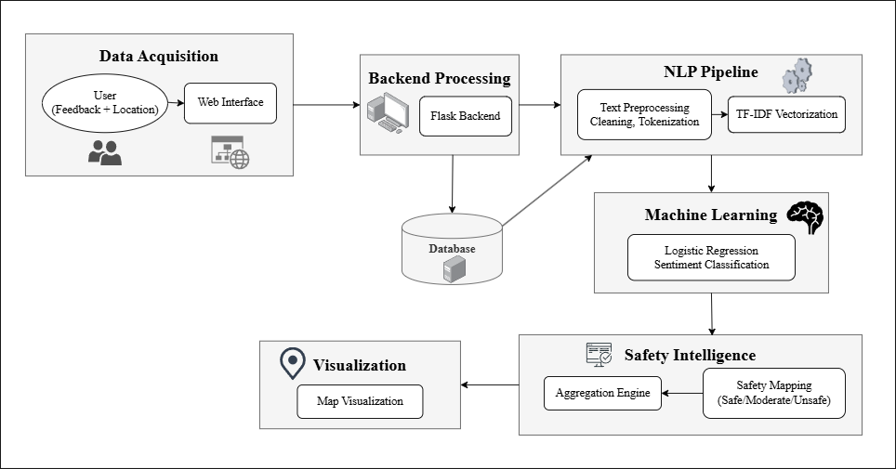
Fig. 1 Overall System Architecture of the Proposed System
Fig. 1 shows the architecture of the proposed AI-based safety perception mapping system. The architecture of the proposed system is shown in the figure, highlighting the different stages in the proposed safety perception mapping system.
  - Data Collection and Preprocessing
The safety-related information is obtained in the form of user feedback in the form of text description and the location where the user experienced the safety-related incident. The dataset has 1,111 instances, obtained from different environments like public places, routes, and even in institutions. Each instance in the dataset has information in the form of a location identifier and a text description of the feedback. For a location $L_{i}$, there might be different feedback instances in the form of a set of size ${[k}_{i}]$. This way, the system will be able to gather information from different user experiences for a single location.
The collected text data is of unstructured nature and may be associated with noise in the form of punctuation symbols, special characters, and redundant words. Therefore, the preprocessing step improves the quality of the text data and maintains uniformity in all the input data. First of all, the text data is cleaned by removing unwanted symbols and irrelevant characters in the text. The text data is changed to lowercase to maintain uniformity in the text. The process of removing stop words is applied to the text data to remove words that are not significant in the text. Finally, the text data is divided into words using the tokenization process because every word in the text is the basic element in this process [30].
  - NLP Processing and Sentiment Classification
Once this pre-processing step is complete, the clean text data is then converted into numerical data using the TF-IDF Vectorizer. This stage creates a feature matrix of dimensionality around [N×V], where N is the number of entries in the feedback data and V is the vocabulary size. This allows for the weighting of words based on their significance within the individual entries of the feedback data as well as the entire data set as a whole. In the feature space, those words that are more significant in the sense of safety perception, such as indicating dangers and uneasiness, get more significance. For classification purposes, this data is then fed into a machine learning algorithm. The sentiment classification algorithm uses Logistic Regression classification technique due to its ability to function on high-dimensional sparse data sets while minimizing computational costs [31]. This classification technique is able to classify the data into three different categories: Positive, Neutral, Negative. Which category the system classifies the data into is indicative of the level of safety that the data is perceiving.

Safety Score Generation and Visualization

The forecasted sentiment labels are then associated with the corresponding safety labels, where the positive sentiment label signifies safety, the neutral sentiment label signifies moderate safety, and the negative sentiment label signifies danger. In a certain location, the total number of feedback entries is combined to come up with a final safety assessment. Given that the total number of feedback entries for a location is $[k]$, where $[nₚ]$ denotes the number of positive predictions, $[nₙ]$ denotes the number of negative predictions, and $[nᵤ]$ denotes the number of neutral predictions, the overall safety assessment can be obtained through the majority rule. By combining several feedback entries, the overall safety assessment is achieved by taking into account the total user experience, thus avoiding any form of bias.
Once the safety levels are computed, they are merged with geographic information and displayed in the form of a map interface. Each location is marked on the map with specific color marker indicating the safety level for the respective location. Safe zone is indicated by green color, while moderate safety is indicated by yellow, and a location of concern is indicated by red. This visualization helps in understanding the safety perception at different locations. It also helps the user understand the safety conditions in an effective manner. This helps in better decision-making and increases the level of user awareness.

- System Implementation
The proposed system consists of modules which comprises of a web user interface, a backend module created using Flask framework and a module for performing machine learning tasks for the sentiment-based safety analysis task. The process of implementing the solution involves use of the pipeline approach whereby the input will be submitted through an HTTP request and processed by the natural language processing model before being classified.
  - Frontend Development
The programming languages to be used in the development of the frontend are HTML, CSS, and JavaScript. The main function of the frontend is to enable the user to express their feelings on their safety by providing them with information on their location and the experience they have had. The frontend communicates with the backend using asynchronous HTTP requests and shows users the predicted sentiment and safety levels. The visualization used for displaying safety levels is based on a map. The colors used for representing the markers depend on the safety levels. Green color is used for representing safe areas, while yellow and red colors are used for representing moderately safe and unsafe areas, respectively.
  - Backend Development
The Python programming language with the Flask framework is used to implement the backend. The backend is an interface for interaction between the frontend and the machine learning model. It provides RESTful endpoints for the client requests. After user input is received, the backend undertakes the preprocessing steps such as text normalization, tokenization, and removal of stop words. The text is then converted into a numerical form using a pre-trained vectorizer and fed into the classification model. Based on the sentiment, a corresponding level of safety is determined. In addition, the backend undertakes tasks related to data handling, processing of coordinates, and data preparation for displaying on a map. Finally, it sends structured data related to the prediction results back to the frontend for display.
  - Machine Learning Model
The proposed system utilizes a supervised machine learning algorithm for sentiment classification of textual data, and for this purpose, a Logistic Regression model has been chosen. Machine learning models require numerical data as input, and hence, textual data is converted into numerical form using TF-IDF Vectorizer. The proposed system uses a Logistic Regression classifier as it performs effectively in linear text classification tasks. It also has low computational complexity and can efficiently operate in high-dimensional sparse space. The model classifies data into three classes: Positive, Neutral, and Negative, which map to Safe, Moderate, and Unsafe conditions in this classifier.
The model is trained offline using the preprocessed data and labels. Once deployed, the model performs real-time prediction using the new user input data without requiring any further training. For efficient deployment, the model and the TF-IDF vectorizer are serialized and saved as pickle files for efficient loading during deployment. This approach is useful to scale up and add complexity to the model with future developments.
Table 2 presents an overview of how the performance of the model is evaluated. As per Table 2, it is evident that the performance is based on how well the classification approach is performing. The performance metrics include accuracy, precision, recall, and F1 scores. The metrics show how reliable the model is with respect to classifying the text-based feedback provided for safety.
Table 2. Model Performance Metrics

Metric | Value
Accuracy | 87%
Precision | 83%
Recall | 82%
F1 Score | 82%

Results and System Interface
The results of the proposed system indicate that the system can efficiently analyze the user safety feedback and transform the feedback into useful safety information. For example, the proposed system can efficiently classify the user input text into positive, neutral, and negative sentiment levels, which can be further transformed into safe, moderate, and unsafe levels. The proposed system can display the results in an interactive web interface, which users can use to understand the levels of safety in various areas.
Fig. 2 below represents the ‘Safety Feedback Submission Interface,’ which users can use to submit their safety feedback by describing the location and the safety experience. The proposed interface is user-friendly, which may encourage the user to provide their safety feedback in detail.

Fig. 3 below shows the Safety Perception Map Visualization, which shows different locations in the form of color-coded markers, where green represents safe locations, yellow represents moderate safety, and red represents unsafe locations. This form of visualization enables the user to interpret the safety levels in an effective manner.

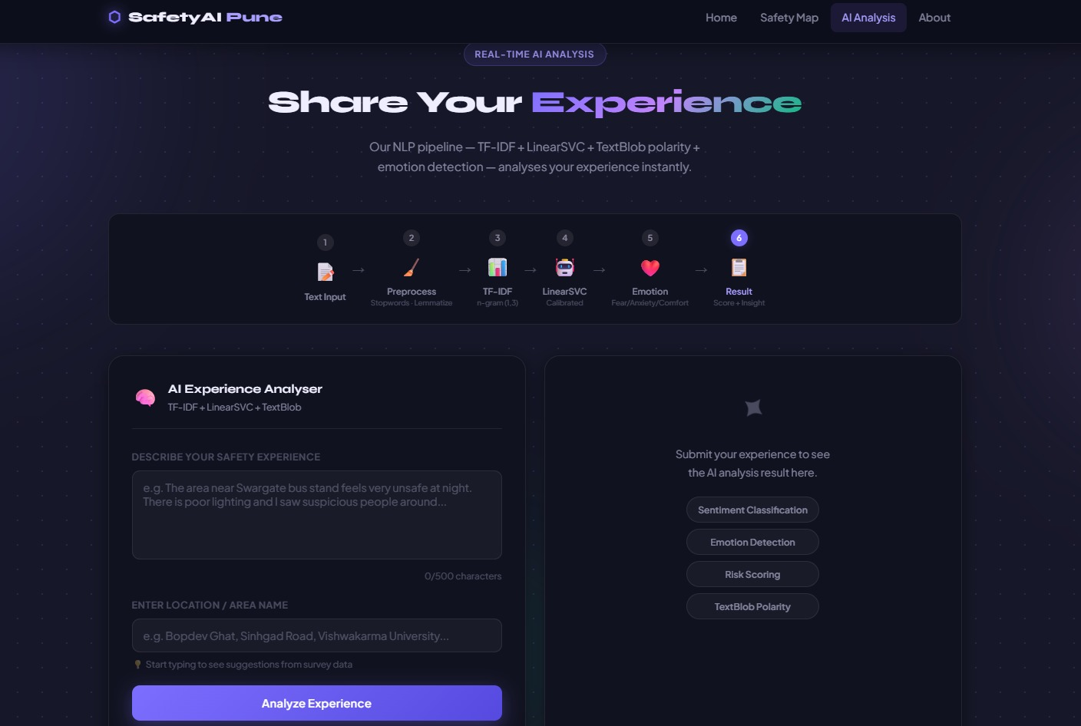

Fig. 2 Safety Feedback Submission Interface
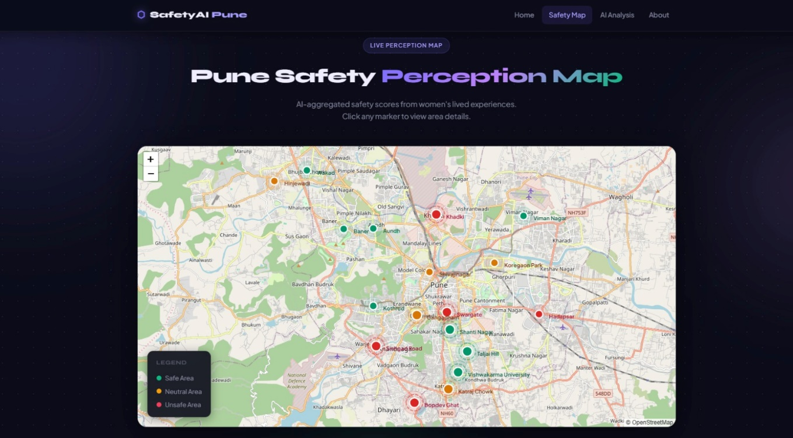

Fig. 3 Safety Perception Map Visualization
Table 3 below represents a sample of feedback, sentiment, and the corresponding predicted levels of risk. It represents how efficiently the model can detect unsafe locations such as those with poor illumination, harassment, and isolation, as well as safe locations, as described by the user.

Table 3. Example Feedback Analysis

Feedback | Sentiment | Risk Level
The place is very unsafe at night and many incidents happen | Negative | Unsafe
Poor lighting and harassment issues make it unsafe to go alone | Negative | Unsafe
Generally safe environment but some outsiders enter without restriction | Neutral | Moderate
Okay during the day but lighting issues make evenings uncomfortable | Neutral | Moderate
Safe area with active community and well-maintained surroundings | Positive | Safe
Very isolated area with lack of police presence and feels unsafe | Negative | Unsafe

Discussions
The suggested solution proves the ability to harness collective intelligence in increasing awareness about security concerns in cities. By gathering user experiences in a particular area, one is able to evaluate their personal safety concerns regardless of any governmental data or statistics regarding crimes. Also, using anonymized feedback helps increase user participation, overcoming social and personal limitations that may prevent a person from sharing potentially useful information. Moreover, visualizing safety levels based on sentiment analysis on maps provides additional opportunities for choosing safe ways and places.

Nevertheless, there are several limitations of the discussed solution that should be taken into account when applying it in real-world conditions. First, crowdsourcing used in this system may lead to the introduction of bias, which means that feedback provided will be provided by those users who will actually have access to smartphones and know how to share data. Secondly, there is a possibility that subjective experience will not correlate with crime statistics, affecting the quality of insights provided.

In terms of a larger social issue, the implementation of AI-powered safety systems carries certain ethical implications. Previous studies suggest the danger of regulatory capture within AI safety [32] that can be defined as a phenomenon when particular organizations can exert their influence over technological systems and regulations for the sake of their interests. In relation to the aforementioned concern, although the suggested safety system supports community-based and distributed data collection processes, it is necessary to pay attention to other aspects such as the ethical use of data gathering, processing, and representation practices. Therefore, despite the fact that this system represents an effective approach to safety perception mapping, its practical application requires responsible actions to be taken.

- Future Scope
The proposed system of safety perception mapping can be improved and modified in the following ways for better scalability and usability. The first significant improvement that can be incorporated in the system is the conversion of the current system from a web application to a cross-platform mobile application using technologies such as React Native or Flutter. This will allow the users to give their feedback and access the safety maps in real-time during their journeys. Moreover, the system would be able to automatically identify the areas using location services and provide users with immediate safety information. Furthermore, the system would be able to notify users of increasing safety risk levels for frequently visited places such as college campuses or daily commutes to cities such as Pune.

Another major feature that is improved in this model is the inclusion of advanced multilingual Natural Language Processing capabilities. In the future, it is also possible to make use of advanced models like mBERT (Multilingual BERT) or XLM-R (Cross-lingual RoBERTa) in handling multilingual text data like Hindi, Marathi, and other regional language variants. Also, TF-IDF vocabularies specific to India can be used to enhance sentiment detection capabilities with words like “eve-teasing” or “isolated area.” This would allow the system to receive input from a larger user base, including the vast percentage of non-English speakers, thereby improving the quality of the dataset.

The system can also be extended to include large-scale data from other sources, which may help improve the accuracy and reliability of the predictions generated by the system. For instance, large-scale data can be obtained from publicly available sources such as NCRB Crime Records, SafetiPin Safety Audits, or municipal complaints, and can be combined with user perception data to form hybrid safety scores. Techniques such as weighted ensemble models can be employed to effectively utilize such large-scale data. Moreover, federated learning can be used to allow training on multiple institutions, thereby keeping user data private, which can extend the system to large-scale data with over 100,000 entries. Associations with women’s safety organizations or NGOs can further assist in collecting high-quality, verified data for fine-tuning the models, thereby converting the system into a comprehensive, large-scale safety intelligence system.

Conclusion
The aim of this paper is to fill an existing gap in the system for women’s safety by proposing an artificial intelligence-based system for mapping safety perceptions using crowdsourced textual experiences. The system will utilize a Python Flask back-end with TF-IDF vectorization and logistic regression to analyze crowdsourced feedback, which will then allow it to generate insights on safety. This system will be trained on actual survey feedback from 1,111 real data points, which will allow it to generate insights on safety patterns at different places based on actual user experiences.
The performance of the proposed model shows the efficiency of the model in processing real-time textual data, where the model shows 87% accuracy, 83% precision, 82% recall, and 82% F1-score. This indicates that the system is able to effectively classify safety perception from the user narrative. The output obtained is further visualized through an easy-to-understand safety map, which is very useful for the users. This safety map would enable the user to have a visual representation of the safety of a particular area, thus enabling them to make appropriate decisions regarding movement.
Unlike other safety apps that have been developed, this proposed safety app would be different in its approach, focusing more on preventive measures rather than reactive measures. This is made possible by its capacity to harness user experience that remains unreported by users whose contributions are anonymous. The current paper has shown the application of machine learning and crowdsourcing of data in coming up with a solution that is scalable as well as respects user privacy.
On a broader level, this study has indicated how machine learning and involvement in data collection could be utilized for the creation of safer urban environments. But this requires careful implementation, as well as the consideration of issues surrounding misuse and discrimination through biased data collection practices. The future could involve improvements in multilingual compatibility and deep learning models for policy applications.

Declarations

Conflict of interest
On behalf of all author(s), the corresponding author states that there is no conflict of interest.

- References

- https://sprf.in/crimes-against-women-in-india-trends-challenges-and-policy-responses/
- https://www.shankariasparliament.com/current-affairs/national-annual-report-and-index-on-womens-safety-nari-2025
- https://www.gktoday.in/national-annual-report-and-index-on-womens-safety-2025/
- Prasad, G. N., Mohan, S. P., Shamshuddin, S. T., Anil, V. P., & Vijay, P. V. (2024, April). Women Safety Analysis based on Twitter (Machine Learning). In 2024 MIT Art, Design and Technology School of Computing International Conference (MITADTSoCiCon) (pp. 1-5). IEEE.
- Pawar, S. S., Roy, R., Sawant, K. V., Singh, R. B., & Navale, M. RescueNow: Real-time SOS and Predictive Women's Safety System.
- Matthewson, G., Kalms, N., Berry, J., & Bawden, G. (2023). Streets after dark: The experiences of women, girls and gender-diverse people. In Everyday Streets: Inclusive approaches to understanding and designing streets (pp. 89-104). UCL Press.
- Kumar, D., & Aggarwal, S. (2019, February). Analysis of women safety in indian cities using machine learning on tweets. In 2019 Amity International Conference on Artificial Intelligence (AICAI) (pp. 159-162). IEEE.
- Patil, Harshali. (2025). Quantitative Sentiment Analysis of Women's Safety Using Twitter Data: An NLP Approach. Journal of Information Systems Engineering and Management. 10. 133-145. 10.52783/jisem.v10i34s.5783. https://doi.org/10.52783/jisem.v10i34s.5783
- Gokulakrishnan, S., Reddy, C. A., & Anudeep, P. V. S. (2022). MACHINE LEARNING OF TWITTER FEEDS AND WOMEN SAFETY IN INDIAN CITIES. Computing Technology Research Journal, 1(1), 12-13.
- Ranjitha, & Nayak, P. (n.d.). Sentiment Classification on Women Safety across Indian Cities Based on Twitter Data using NLP and Machine Learning. Retrieved March 25, 2026, from https://ijirt.org/publishedpaper/IJIRT156041_PAPER.pdf
- https://ijsrem.com/download/machine-learning-for-womens-safety-based-on-analysis-of-tweets/
- Ranjini, M., Vignesh Muruga, M., & Krithick, R. (2025). Evaluating Women Safety in Urban Areas Using Machine Learning. International Journal of Advanced Research in Science, Communication and Technology International Open-Access, Double-Blind, Peer-Reviewed, Refereed, Multidisciplinary Online Journal, 5(3). https://doi.org/10.48175/IJARSCT-26351
- Verma, M., Rodeja, N., Manoj, M., & Verma, A. (2020). Young Women’s Perception of Safety in Public Buses: A Study of Two Indian Cities (Ahmedabad and Bangalore). Transportation Research Procedia, 48, 3254–3263. https://doi.org/10.1016/j.trpro.2020.08.151
- M. V. Shenoy, S. Sridhar, G. Salaka, A. Gupta and R. Gupta, "A Holistic Framework for Crime Prevention, Response, and Analysis With Emphasis on Women Safety Using Technology and Societal Participation," in IEEE Access, vol. 9, pp. 66188-66207, 2021, doi: 10.1109/ACCESS.2021.3076016
- Gargiulo, I., Garcia, X., Benages-Albert, M., Martinez, J., Pfeffer, K., & Vall-Casas, P. (2020). Women’s safety perception assessment in an urban stream corridor: Developing a safety map based on qualitative GIS. Landscape and Urban Planning, 198, 103779. https://doi.org/10.1016/j.landurbplan.2020.103779
- Chen, S., Lin, S., Yao, Y., & Zhou, X. (2024). Urban Public Space Safety Perception and the Influence of the Built Environment from a Female Perspective: Combining Street View Data and Deep Learning. Land, 13(12), 2108. https://doi.org/10.3390/land13122108
- Torrao, G., Htait, A., & Wong, S. H. S. (2024). Perceptions of Women’s Safety in Transient Environments and the Potential Role of AI in Enhancing Safety: An Inclusive Mobility Study in India. Sustainability, 16(19), 8631. https://doi.org/10.3390/su16198631
- Le, T. (2022). Crowdsourcing Women’s Experiences of Space: Empowerment, (In)Visibility, and Exclusions – A Critical Reading of Safetipin Map. Platform: Journal of Media and Communication, 43–55. https://doi.org/10.46580/p62073
- Rao, P. (2025). AI-Driven Women Safety Analytics: A Proactive Threat Detection System. International Journal of Creative Research Thoughts (IJCRT) Www.ijcrt.org C177, 13(5), 2320–2882. https://www.ijcrt.org/papers/IJCRT2505246.pdf
- https://www.researchgate.net/publication/373458222
- Daga, D., Saikia, H., Bhattacharjee, S., & Saha, B. (2021). A Conceptual Design Approach for Women Safety Through Better Communication Design. International Journal of Electronics Engineering and Applications, IX(III), 01. https://doi.org/10.30696/ijeea.ix.iii.2021.01-11
- Sridhar Mandapati, Pamidi, S., & Ambati, S. (2015). A Mobile Based Women Safety Application (I Safe Apps). 17(1), 29–34. https://doi.org/10.9790/0661-17112934
- Kavitha Gokulprasanth, J., & Ajith Kumar. (2023). Intelligent Safety System For Women Security. 11, 2320–2882. https://ijcrt.org/papers/IJCRT2305890.pdf
- Wasim Akram, Mohit Jain, C. Sweetlin Hemalatha, Design of a Smart Safety Device for Women using IoT, Procedia Computer Science,Volume 165, 2019 Pages 656-662, ISSN 1877-0509, https://doi.org/10.1016/j.procs.2020.01.060.
- Artificial-Intelligence_-A-Smart-and-Empowering-Approach-to-Womens-Safety(2023) Scribd. https://www.scribd.com/document/799151380/Artificial-Intelligence-A-Smart-and-Empowering-Approach-to-Womens-Safety
- Wagh, N. R., Sutar, S. R., Kadam, V. J., Jadhav, S. M., Yadav, A. S., & Pawar, V. S. (2025). Evaluation of IoT based smart safety systems for women and children using machine learning techniques. Scientific Reports.
- Cáceres García de Marina, P., Cuadra Fernández, D., Sierra Alonso, A., & Vela Sánchez, B. (2025). Enhancing safety in urban mobility with female digital twins. AI & SOCIETY, 1-15.
- Jnr, B. A. (2025). User-centered AI-based voice-assistants for safe mobility of older people in urban context. AI & SOCIETY, 40(2), 545-568.
- Salton, G., & Buckley, C. (1988). Term-weighting approaches in automatic text retrieval. Information processing & management, 24(5), 513-523.
- Bird, S., Klein, E., & Loper, E. (2009). Natural language processing with Python: analyzing text with the natural language toolkit. " O'Reilly Media, Inc.".
- Hosmer Jr, D. W., Lemeshow, S., & Sturdivant, R. X. (2013). Applied logistic regression. John Wiley & Sons.
- Metcalf, T. (2025). AI safety and regulatory capture. AI & SOCIETY, 1-16.

